Bitcoin Price Prediction

1. INTRODUCTION:
This project deals with the bitcoin price, which fluctuates on a daily basis. Bitcoin, if we need to explain about it in a simple manner, we can consider it as a computer file that is basically stored in a digital wallet application or in the computer. We can send a bitcoin as a whole or a part of it to other people, which gets recorded in a public transaction list that is referred to by the term ‘blockchain’. The domain our project belongs to is Machine Learning which is a type of Artificial Intelligence that is a part of data science. Data science can be considered a field of study and development that revolves around information and data. Artificial Intelligence (AI) can be considered a part of data science and Machine Learning (ML), comes under AI. Data science deals with processing and analyzing data with a motive for producing useful stuff that can be used in many ways out of the data. Artificial Intelligence can be considered as a part of Data Science, that deals with stimulating the machine, i.e. computer, with human knowledge. This helps the machines/ computers to behave in a very human-like manner. It is implemented using many ways of learning like deep learning, machine learning, etc. Here we have used machine learning. A. Machine Learning Machine Learning is more about prediction kind rather than the learn and behave kind. What machine learning does is, it makes the system take a good deal of past data and by using various algorithms and techniques it can make predictions corresponding to the data, and it learns how to do it automatically by itself from those algorithms. Simple example of ML is that we can take all of the cat family member’s pictures and boost our ML model with algorithms and the names of the members which will be human fed. We train the model with the past images collected, and test it on new images, we can see that the machine has learned to identify the newer images as cats or not. We people use ML in our daily lives, if we are able to use Google photos the well-known photo gallery application from Google LLC gathers photos of us and it asks us questions along with our various images, like “Is this the same person?”, if we feed data on a regular basis for a week, we can see that almost 99% of our data is being classified and organized neatly, for each and every person in the pictures in our gallery. Nowadays, ML is one of the fields that is soaring in the IT sector, as we can see so many automated services and devices in many other sectors too. Machine Learning is a part of Artificial Intelligence (AI), where the production of next generation humanoid- robots. These robots can be used in various fields from military to medicine. There are even robots that are being made to perform operations and other medical treatments. From all the research and developments that are taking place in a rapid manner, we can clearly see that our future has an irreplaceable place for machine learning and artificial intelligence.
1.1 Objective of the project:
Presenting Bitcoin Price Prediction Using ML, a machine learning model that is implemented with certain algorithms to deduce the price of bitcoin with the given other details of the factors that influence the bitcoin price directions. Recently, bitcoin has reached a new peak in its popularity due to the law enforcements for tax deductions from the profits gained from bitcoin investments and returns in India. Bitcoin is a digital asset and a payment system that is used as a form of Internet currency. It allows for anonymous payment from one person to another and is therefore a preferred payment method for criminal actions on the Internet. Recently Bitcoin has received a lot of attention from the media and the public due to its recent price hike. The objective of this paper is to determine the predictable price direction of Bitcoin price. Machine learning models can likely give us the insight we need to learn about the future of Cryptocurrency. It will not tell us the future but it might tell us the general trend and direction to expect the prices to move. The proposed model is to build a machine learning model where the data is used to learn about the pattern in the dataset and the machine learning algorithm is used to predict the bitcoin price based on the directly affecting biases. With the effective feedback from the domain experts, we were able to approach the better version of the bitcoin price prediction model
2. LITERATURE SERVUY:

1. Yang Li, Zibin Zheng and Hong-Ning Dai (2019) [1] Investigates the Bitcoin price fluctuation prediction problem, which can be described as whether Bitcoin price keeps or reverses after a large fluctuation by using three kinds of features including basic features, traditional technical trading indicators, and features generated by a Denoising autoencoder. The evaluation of these features is done by using an Attentive LSTM network and an Embedding Network (ALEN). Also investigates the impact of parameters on the Bitcoin price fluctuation prediction problem, which can be further used in a real trading environment by investors.

2. Lekkala Sreekanth Reddy, Dr.P. Sriramya (2020) [2] Nowadays many papers have accurate prices but some others don’t, but the time complexity is higher in those predictions, so to reduce the time complexity here in this paper they used an algorithm linked to artificial intelligence named LASSO (least absolute shrinkage selection operator).

3. Shivam Pandey, Mr.Anil Chavan, [3] (2021) In the first phase, this paper aims to understand and identify daily trends in the Bitcoin market while gaining insight into optimal features surrounding Bitcoin price. For the second phase of our survey, using the available information, it focuses on prediction of the sign of the daily price change. In this project they have attempted to predict the prices of Bitcoins using two deep learning methodologies.

4. Muhammad Ali Nasir1, Toan Luu Duc Huynh (2021) [4] Considering all the debate on the role of cryptocurrencies in the current economy as well as their dynamics and forecasting, this brief study analyzes the predictability of Bitcoin volume and returns using Google search values.

5. David Garcia and Frank Schweitzer (2015) [5] This paper illustrates the increases in opinion polarization and exchange volume precede rising Bitcoin prices, and that emotional valence precedes opinion polarization and rising exchange volumes. Applying these insights to design algorithmic trading strategies for Bitcoin, reached very high profits in less than a year. Verified using robust statistical methods that take into account risk and trading costs, confirming the longstanding hypothesis that trading-based social media sentiment has the potential to yield positive returns on investment.

6. Ruchi Mital ,Shefali Arora and M.P.S. Bhatia (2018) [6] This price prediction helps the number of users who are using cryptocurrencies for multiple types of transactions.They used deep learning models like LSTM to analyze various cryptocurrencies.The main drawback is that they might not have enough information for long-term analysis.

7. Alireza Ashayer (2019) [7] Two performance metrics for each model were measured: mean squared error and the accuracy of the model in predicting the direction of price movement for the next day. To enable a meaningful comparison between the mean squared error value among different cryptocurrencies, daily closing prices were normalized before being used by the models.

8. Neha Mangla, Akshay Bhat, Ganesh Avabratha, Narayana Bhat. (2019) [8] In this paper they used the previous timestamps to develop a predictive model, by using the ARIMA and RNN methods, yet this kind of predictive model does not meet the requirement of fulfilling the long term efficiency condition.

3. SYSTEM ANALYSIS
3.1 Existing System
In Existing System As far as bitcoin is concerned there are many research papers and other models that are built to deploy a machine learning model. Bitcoin and other cryptocurrencies are still a vaguely known concept from the public's eye. People get to know all kinds of negative criticisms and rumours faster than the good things. Majority of them know that even though bitcoin has high returns on investing, it has even more risk factors yet what people do is they do not fact check those information’s and believe them as it is and they spread the false rumours to other people too. There are so many ridiculous rumours about bitcoin and other cryptocurrencies like they are only used for illegal and illicit purposes and that they are not secure. These kinds of false myths leave a really bad impression on these cryptocurrencies with people. So many researchers even hesitate at times to do projects and research surveys about these topics. As days go by people get every news in their hand as it is, so their minds are getting cleared about such topics and they really started to focus on what this bitcoin is actually about. Even though there are many articles and projects that are greatly viewed and appreciated related to bitcoin, still the negative view will not fade that easily from the minds of people. There are many systems that are currently existing for bitcoin related projects and even for the price prediction model, many people have used all kinds of algorithms where they still didn't get to cover some drawbacks. Some commonly found drawbacks in the previously done projects are:
● Existing models are made for only data analysis and a predicting model was not built.
● The classification model was not discussed and performance metrics like accuracy are not calculated.
Disadvantages:
1.Less Prediction.
2.Security is Less.
3.Less Accuracy.
3.2 Proposed System
In this project we are using Subspace Learning Algorithm called Supervised Principal Coefficients Embedding (SPCE) to reduce high dimension data into low dimension. In machine learning all algorithms get trained on past datasets and this dataset often contains irrelevant (unimportant) features and this feature will be removed by applying SPCE algorithm. SPCE algorithm will find coefficients or fitness or each attribute by calculating accuracy and whatever features gave high accuracy will be selected and remaining attributes will be removed out.
In this project we are using Blockchain technology to store BITCOIN historic price data. This data will be retrieved by machine learning algorithms such as Logistic Regression, Support Vector Machine and ARIMA. This algorithm will get trained on this data and then predict future price of Bitcoin.
In all algorithms Logistic Regression is giving accurate prediction prices. To calculate performance of each algorithm we have divided dataset into train and test where application used 80% dataset for training and 20% dataset for testing. After training model, we will apply test data on trained model to predict prices and this prices will be check with original prices and if there is not much difference between original and predicted prices then algorithm will be consider as accurate.

Advantages:
1.Gives more Accuracy.
2.More Secure.
Modules:
- Load Bitcoin Data from Blockchain
- Preprocess Dataset
- Run Subspace Learning SPCE Algorithm
- Run SVM Algorithm
- Run Logistic Regression Algorithm
- Run ARIMA Algorithm
3.3. PROCESS MODEL USED WITH JUSTIFICATION
SDLC (Umbrella Model):
Umbrella Activity
Umbrella Activity
Umbrella Activity
- Feasibility Study
- TEAM FORMATION
- Project Specification PREPARATION

Business Requirement Documentation
ANALYSIS & DESIGN
CODE
UNIT TEST
DOCUMENT CONTROL

ASSESSMENT

TRAINING
INTEGRATION & SYSTEM TESTING

DELIVERY/INSTALLATION
ACCEPTANCE TEST
Requirements Gathering
SDLC is nothing but Software Development Life Cycle. It is a standard which is used by software industry to develop good software.
Stages in SDLC:
- Requirement Gathering
- Analysis
- Designing
- Coding
- Testing
- Maintenance
Requirements Gathering stage:
The requirements gathering process takes as its input the goals identified in the high-level requirements section of the project plan. Each goal will be refined into a set of one or more requirements. These requirements define the major functions of the intended application, define operational data areas and reference data areas, and define the initial data entities. Major functions include critical processes to be managed, as well as mission critical inputs, outputs and reports. A user class hierarchy is developed and associated with these major functions, data areas, and data entities. Each of these definitions is termed a Requirement. Requirements are identified by unique requirement identifiers and, at minimum, contain a requirement title and textual description.
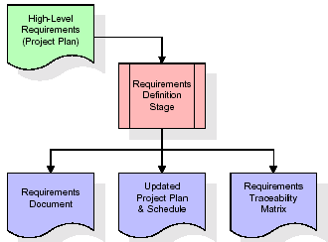
These requirements are fully described in the primary deliverables for this stage: the Requirements Document and the Requirements Traceability Matrix (RTM). The requirements document contains complete descriptions of each requirement, including diagrams and references to external documents as necessary. Note that detailed listings of database tables and fields are not included in the requirements document.
The title of each requirement is also placed into the first version of the RTM, along with the title of each goal from the project plan. The purpose of the RTM is to show that the product components developed during each stage of the software development lifecycle are formally connected to the components developed in prior stages.
In the requirements stage, the RTM consists of a list of high-level requirements, or goals, by title, with a listing of associated requirements for each goal, listed by requirement title. In this hierarchical listing, the RTM shows that each requirement developed during this stage is formally linked to a specific product goal. In this format, each requirement can be traced to a specific product goal, hence the term requirements traceability.
The outputs of the requirements definition stage include the requirements document, the RTM, and an updated project plan.
- Feasibility study is all about identification of problems in a project.
- No. of staff required to handle a project is represented as Team Formation, in this case only modules are individual tasks will be assigned to employees who are working for that project.
- Project Specifications are all about representing of various possible inputs submitting to the server and corresponding outputs along with reports maintained by administrator.
Analysis Stage:
The planning stage establishes a bird's eye view of the intended software product, and uses this to establish the basic project structure, evaluate feasibility and risks associated with the project, and describe appropriate management and technical approaches.
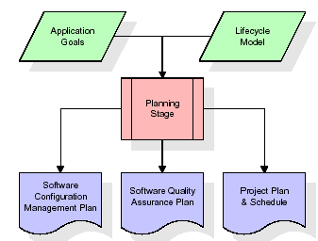
The most critical section of the project plan is a listing of high-level product requirements, also referred to as goals. All of the software product requirements to be developed during the requirements definition stage flow from one or more of these goals. The minimum information for each goal consists of a title and textual description, although additional information and references to external documents may be included. The outputs of the project planning stage are the configuration management plan, the quality assurance plan, and the project plan and schedule, with a detailed listing of scheduled activities for the upcoming Requirements stage, and high level estimates of effort for the out stages.
Designing Stage:
The design stage takes as its initial input the requirements identified in the approved requirements document. For each requirement, a set of one or more design elements will be produced as a result of interviews, workshops, and/or prototype efforts. Design elements describe the desired software features in detail, and generally include functional hierarchy diagrams, screen layout diagrams, tables of business rules, business process diagrams, pseudo code, and a complete entity-relationship diagram with a full data dictionary. These design elements are intended to describe the software in sufficient detail that skilled programmers may develop the software with minimal additional input.

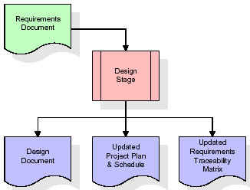
When the design document is finalized and accepted, the RTM is updated to show that each design element is formally associated with a specific requirement. The outputs of the design stage are the design document, an updated RTM, and an updated project plan.
Development (Coding) Stage:
The development stage takes as its primary input the design elements described in the approved design document. For each design element, a set of one or more software artifacts will be produced. Software artifacts include but are not limited to menus, dialogs, and data management forms, data reporting formats, and specialized procedures and functions. Appropriate test cases will be developed for each set of functionally related software artifacts, and an online help system will be developed to guide users in their interactions with the software.
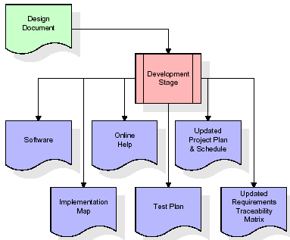

The RTM will be updated to show that each developed artifact is linked to a specific design element, and that each developed artifact has one or more corresponding test case items. At this point, the RTM is in its final configuration. The outputs of the development stage include a fully functional set of software that satisfies the requirements and design elements previously documented, an online help system that describes the operation of the software, an implementation map that identifies the primary code entry points for all major system functions, a test plan that describes the test cases to be used to validate the correctness and completeness of the software, an updated RTM, and an updated project plan.
Integration & Test Stage:
During the integration and test stage, the software artifacts, online help, and test data are migrated from the development environment to a separate test environment. At this point, all test cases are run to verify the correctness and completeness of the software. Successful execution of the test suite confirms a robust and complete migration capability. During this stage, reference data is finalized for production use and production users are identified and linked to their appropriate roles. The final reference data (or links to reference data source files) and production user list are compiled into the Production Initiation Plan.
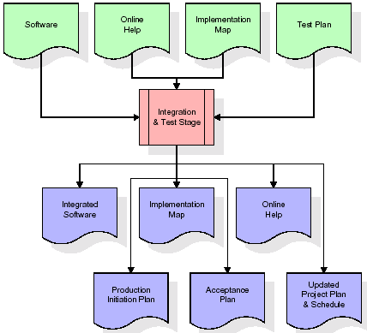
The outputs of the integration and test stage include an integrated set of software, an online help system, an implementation map, a production initiation plan that describes reference data and production users, an acceptance plan which contains the final suite of test cases, and an updated project plan.
- Installation & Acceptance Test:
During the installation and acceptance stage, the software artifacts, online help, and initial production data are loaded onto the production server. At this point, all test cases are run to verify the correctness and completeness of the software. Successful execution of the test suite is a prerequisite to acceptance of the software by the customer.
After customer personnel have verified that the initial production data load is correct and the test suite has been executed with satisfactory results, the customer formally accepts the delivery of the software.
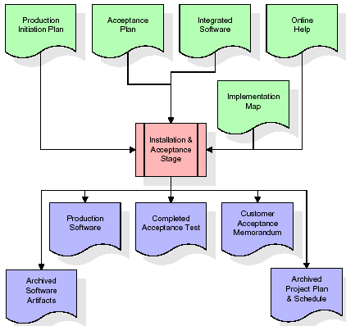
The primary outputs of the installation and acceptance stage include a production application, a completed acceptance test suite, and a memorandum of customer acceptance of the software. Finally, the PDR enters the last of the actual labor data into the project schedule and locks the project as a permanent project record. At this point the PDR "locks" the project by archiving all software items, the implementation map, the source code, and the documentation for future reference.
Maintenance:
Outer rectangle represents maintenance of a project, Maintenance team will start with requirement study, understanding of documentation later employees will be assigned work and they will undergo training on that particular assigned category. For this life cycle there is no end, it will be continued so on like an umbrella (no ending point to umbrella sticks).
3.4. Software Requirement Specification
3.4.1. Overall Description
A Software Requirements Specification (SRS) – a requirements specification for a software system is a complete description of the behavior of a system to be developed. It includes a set of use cases that describe all the interactions the users will have with the software. In addition to use cases, the SRS also contains non-functional requirements. Nonfunctional requirements are requirements which impose constraints on the design or implementation (such as performance engineering requirements, quality standards, or design constraints).
System requirements specification: A structured collection of information that embodies the requirements of a system. A business analyst, sometimes titled system analyst, is responsible for analyzing the business needs of their clients and stakeholders to help identify business problems and propose solutions. Within the systems development lifecycle domain, the BA typically performs a liaison function between the business side of an enterprise and the information technology department or external service providers. Projects are subject to three sorts of requirements:
- Business requirements describe in business terms what must be delivered or accomplished to provide value.
- Product requirements describe properties of a system or product (which could be one of several ways to accomplish a set of business requirements.)
- Process requirements describe activities performed by the developing organization. For instance, process requirements could specify .Preliminary investigation examine project feasibility, the likelihood the system will be useful to the organization. The main objective of the feasibility study is to test the Technical, Operational and Economical feasibility for adding new modules and debugging old running system. All system is feasible if they are unlimited resources and infinite time. There are aspects in the feasibility study portion of the preliminary investigation:
- ECONOMIC FEASIBILITY
A system can be developed technically and that will be used if installed must still be a good investment for the organization. In the economical feasibility, the development cost in creating the system is evaluated against the ultimate benefit derived from the new systems. Financial benefits must equal or exceed the costs. The system is economically feasible. It does not require any addition hardware or software. Since the interface for this system is developed using the existing resources and technologies available at NIC, There is nominal expenditure and economical feasibility for certain.
- Operational Feasibility
Proposed projects are beneficial only if they can be turned out into information system. That will meet the organization’s operating requirements. Operational feasibility aspects of the project are to be taken as an important part of the project implementation. This system is targeted to be in accordance with the above-mentioned issues. Beforehand, the management issues and user requirements have been taken into consideration. So there is no question of resistance from the users that can undermine the possible application benefits. The well-planned design would ensure the optimal utilization of the computer resources and would help in the improvement of performance status.
- TECHNICAL FEASIBILITY
Earlier no system existed to cater to the needs of ‘Secure Infrastructure Implementation System’. The current system developed is technically feasible. It is a web based user interface for audit workflow at NIC-CSD. Thus it provides an easy access to .the users. The database’s purpose is to create, establish and maintain a workflow among various entities in order to facilitate all concerned users in their various capacities or roles. Permission to the users would be granted based on the roles specified. Therefore, it provides the technical guarantee of accuracy, reliability and security.
3.4.2. External Interface Requirements
User Interface
The user interface of this system is a user friendly python Graphical User Interface.
Hardware Interfaces
The interaction between the user and the console is achieved through python capabilities.
Software Interfaces
The required software is python.
Operating Environment
Windows XP.
HARDWARE REQUIREMENTS:

Processor - Pentium –IV
- Speed - 1.1 Ghz
- RAM - 256 MB(min)
- Hard Disk - 20 GB
SOFTWARE REQUIREMENTS:
- Operating System - Windows7/8
- Programming Language - Python 3.7.0
4. SYSTEM DESIGN
UML Diagram:
Class Diagram:
The class diagram is the main building block of object oriented modeling. It is used both for general conceptual modeling of the systematic of the application, and for detailed modeling translating the models into programming code. Class diagrams can also be used for data modeling. The classes in a class diagram represent both the main objects, interactions in the application and the classes to be programmed. In the diagram, classes are represented with boxes which contain three parts:
- The upper part holds the name of the class
- The middle part contains the attributes of the class
- The bottom part gives the methods or operations the class can take or undertake
Class Diagram:
Use case Diagram:
A use case diagram at its simplest is a representation of a user's interaction with the system and depicting the specifications of a use case. A use case diagram can portray the different types of users of a system and the various ways that they interact with the system. This type of diagram is typically used in conjunction with the textual use case and will often be accompanied by other types of diagrams as well.
Use case Diagram:

Sequence diagram:
A sequence diagram is a kind of interaction diagram that shows how processes operate with one another and in what order. It is a construct of a Message Sequence Chart. A sequence diagram shows object interactions arranged in time sequence. It depicts the objects and classes involved in the scenario and the sequence of messages exchanged between the objects needed to carry out the functionality of the scenario. Sequence diagrams are typically associated with use case realizations in the Logical View of the system under development. Sequence diagrams are sometimes called event diagrams, event scenarios, and timing diagrams.
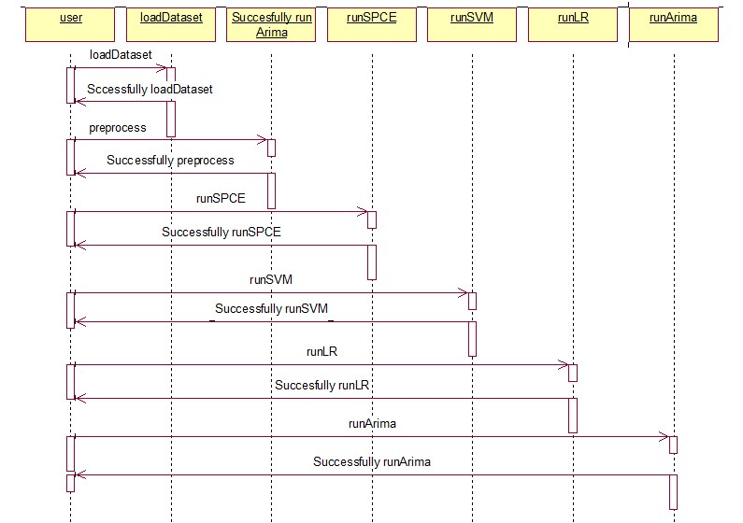

Collaboration diagram:
A collaboration diagram describes interactions among objects in terms of sequenced messages. Collaboration diagrams represent a combination of information taken from class, sequence, and use case diagrams describing both the static structure and dynamic behavior of a system.

Component Diagram:
In the Unified Modeling Language, a component diagram depicts how components are wired together to form larger components and or software systems. They are used to illustrate the structure of arbitrarily complex systems.
Components are wired together by using an assembly connector to connect the required interface of one component with the provided interface of another component. This illustrates the service consumer - service provider relationship between the two components.
Component Diagram:

Deployment Diagram:
A deployment diagram in the Unified Modeling Language models the physical deployment of artifacts on nodes. To describe a web site, for example, a deployment diagram would show what hardware components ("nodes") exist (e.g., a web server, an application server, and a database server), what software components ("artifacts") run on each node (e.g., web application, database), and how the different pieces are connected (e.g. JDBC, REST, RMI).
The nodes appear as boxes, and the artifacts allocated to each node appear as rectangles within the boxes. Nodes may have sub nodes, which appear as nested boxes. A single node in a deployment diagram may conceptually represent multiple physical nodes, such as a cluster of database servers.
Deployment Diagram:

Activity Diagram:
Activity diagram is another important diagram in UML to describe dynamic aspects of the system. It is basically a flow chart to represent the flow form one activity to another activity. The activity can be described as an operation of the system. So, the control flow is drawn from one operation to another. This flow can be sequential, branched or concurrent

Load Bitcoin Data fromBlockchain

Preprocess Dataset

Run Subspace Learning SPCE Algorithm

Run SVM Algorithm

Run SVM Algorithm

Run SVM Algorithm

Data Flow Diagram:
Data flow diagrams illustrate how data is processed by a system in terms of inputs and outputs. Data flow diagrams can be used to provide a clear representation of any business function. The technique starts with an overall picture of the business and continues by analyzing each of the functional areas of interest. This analysis can be carried out in precisely the level of detail required. The technique exploits a method called top-down expansion to conduct the analysis in a targeted way.
As the name suggests, Data Flow Diagram (DFD) is an illustration that explicates the passage of information in a process. A DFD can be easily drawn using simple symbols. Additionally, complicated processes can be easily automated by creating DFDs using easy-to-use, free downloadable diagramming tools. A DFD is a model for constructing and analyzing information processes. DFD illustrates the flow of information in a process depending upon the inputs and outputs. A DFD can also be referred to as a Process Model. A DFD demonstrates business or technical process with the support of the outside data saved, plus the data flowing from the process to another and the end results.
User
  - Load Bitcoin Data from Blockchain 2. Successfully Load Bitcoin Data from Blockchain
- Preprocess Dataset 4. Successfully Preprocess Dataset
- Run Subspace Learning SPCE Algorithm 6. Successfully Run Subspace Learning SPCE Algorithm
7. Run SVM Algorithm 8. Successfully Run SVM Algorithm
9. Run Logistic Regression Algorithm 10. Successfully Run Logistic Regression Algorithm
11. Run ARIMA Algorithm 12. Successfully Run ARIMA Algorithm

System

5. IMPLEMETATION
5.1 Python
Python is a general-purpose language. It has wide range of applications from Web development (like: Django and Bottle), scientific and mathematical computing (Orange, SymPy, NumPy) to desktop graphical user Interfaces (Pygame, Panda3D). The syntax of the language is clean and length of the code is relatively short. It's fun to work in Python because it allows you to think about the problem rather than focusing on the syntax.
History of Python:
Python is a fairly old language created by Guido Van Rossum. The design began in the late 1980s and was first released in February 1991.
Why Python was created?
In late 1980s, Guido Van Rossum was working on the Amoeba distributed operating system group. He wanted to use an interpreted language like ABC (ABC has simple easy-to-understand syntax) that could access the Amoeba system calls. So, he decided to create a language that was extensible. This led to design of a new language which was later named Python.
Why the name Python?
No. It wasn't named after a dangerous snake. Rossum was fan of a comedy series from late seventies. The name "Python" was adopted from the same series "Monty Python's Flying Circus".
Features of Python:
A simple language which is easier to learn
Python has a very simple and elegant syntax. It's much easier to read and write Python programs compared to other languages like: C++, Java, C#. Python makes programming fun and allows you to focus on the solution rather than syntax.
If you are a newbie, it's a great choice to start your journey with Python.
Free and open-source
You can freely use and distribute Python, even for commercial use. Not only can you use and distribute software’s written in it, you can even make changes to the Python's source code.
Python has a large community constantly improving it in each iteration.
Portability
You can move Python programs from one platform to another, and run it without any changes.
It runs seamlessly on almost all platforms including Windows, Mac OS X and Linux.
Extensible and Embeddable
Suppose an application requires high performance. You can easily combine pieces of C/C++ or other languages with Python code.
This will give your application high performance as well as scripting capabilities which other languages may not provide out of the box.
A high-level, interpreted language
Unlike C/C++, you don't have to worry about daunting tasks like memory management, garbage collection and so on.
Likewise, when you run Python code, it automatically converts your code to the language your computer understands. You don't need to worry about any lower-level operations.
Large standard libraries to solve common tasks
Python has a number of standard libraries which makes life of a programmer much easier since you don't have to write all the code yourself. For example: Need to connect MySQL database on a Web server? You can use MySQLdb library using import MySQLdb .
Standard libraries in Python are well tested and used by hundreds of people. So you can be sure that it won't break your application.
Object-oriented
Everything in Python is an object. Object oriented programming (OOP) helps you solve a complex problem intuitively.
With OOP, you are able to divide these complex problems into smaller sets by creating objects.
Applications of Python:
1. Simple Elegant Syntax
Programming in Python is fun. It's easier to understand and write Python code. Why? The syntax feels natural. Take this source code for an example:
a = 2
b = 3
sum = a + b
print(sum)
2. Not overly strict
You don't need to define the type of a variable in Python. Also, it's not necessary to add semicolon at the end of the statement.
Python enforces you to follow good practices (like proper indentation). These small things can make learning much easier for beginners.
3. Expressiveness of the language
Python allows you to write programs having greater functionality with fewer lines of code. Here's a link to the source code of Tic-tac-toe game with a graphical interface and a smart computer opponent in less than 500 lines of code. This is just an example. You will be amazed how much you can do with Python once you learn the basics.
4. Great Community and Support
Python has a large supporting community. There are numerous active forums online which can be handy if you are stuck.
5.2 Sample Code:
from tkinter import *
import tkinter
from tkinter import filedialog
import numpy as np
from tkinter import simpledialog
from sklearn.model_selection import train_test_split
from tkinter import ttk
from tkinter.filedialog import askopenfilename
import os
import json
from web3 import Web3, HTTPProvider

import pandas as pd
from sklearn.preprocessing import StandardScaler
from sklearn.preprocessing import MinMaxScaler
from sklearn.metrics import mean_squared_error
from sklearn.svm import SVR
import matplotlib.pyplot as plt
from sklearn.model_selection import train_test_split
from sklearn.linear_model import LinearRegression

plt.style.use('fivethirtyeight')
from pylab import rcParams
rcParams['figure.figsize'] = 10, 6
from statsmodels.tsa.stattools import adfuller
from statsmodels.tsa.seasonal import seasonal_decompose
from statsmodels.tsa.arima_model import ARIMA
from pmdarima.arima import auto_arima
from sklearn.metrics import mean_squared_error, mean_absolute_error
import math

main = tkinter.Tk()
main.title("Bitcoin Price Prediction") #designing main screen
main.geometry("1000x650")

global X,Y
global X_train, X_test, Y_train, Y_test
global dataset, sc

def saveToBlockchain(data):
blockchain_address = 'http://127.0.0.1:9545'
web3 = Web3(HTTPProvider(blockchain_address))
web3.eth.defaultAccount = web3.eth.accounts[0]
compiled_contract_path = 'Bitcoin.json' #bitcoin contract file
deployed_contract_address = '0x1DD4fb45C1cdC8C3f32cbaA60464c8107D4D4058' #contract address
with open(compiled_contract_path) as file:
contract_json = json.load(file) # load contract info as JSON
contract_abi = contract_json['abi'] # fetch contract's abi - necessary to call its functions
file.close()
contract = web3.eth.contract(address=deployed_contract_address, abi=contract_abi)
msg = contract.functions.setData(data).transact()
tx_receipt = web3.eth.waitForTransactionReceipt(msg)

def readDetails():
details = ""
blockchain_address = 'http://127.0.0.1:9545' #Blokchain connection IP
web3 = Web3(HTTPProvider(blockchain_address))
web3.eth.defaultAccount = web3.eth.accounts[0]
compiled_contract_path = 'Bitcoin.json' #Bitcoin contract code
deployed_contract_address = '0x1DD4fb45C1cdC8C3f32cbaA60464c8107D4D4058' #hash address to access student contract
with open(compiled_contract_path) as file:
contract_json = json.load(file) # load contract info as JSON
contract_abi = contract_json['abi'] # fetch contract's abi - necessary to call its functions
file.close()
contract = web3.eth.contract(address=deployed_contract_address, abi=contract_abi) #now calling contract to access data
details = contract.functions.getData().call()
return details

def SPCE(high_dimension_data):
qq = high_dimension_data
X = qq
X_scaled = StandardScaler().fit_transform(X)
features = X_scaled.T
solution = np.cov(features)
values, vectors = np.linalg.eig(solution)
fitness = []
for i in range(len(values)):
fitness.append(round(values[i] / np.sum(values),8))
update_position = np.sort(fitness)[::-1]
selected = np.zeros(len(fitness))
for i in range(0,4):
for j in range(len(fitness)):
if update_position[i] == fitness[j]:
selected[j] = 1
X_selected_features = X[:,selected==1]
X_scaled = StandardScaler().fit_transform(X_selected_features)
return X_selected_features

def loadDataset():
text.delete('1.0', END)
global dataset
data = readDetails()
f = open("temp.csv", "w")
f.write(data)
f.close()

dataset = pd.read_csv("Dataset/Bitcoin-USD.csv")
text.insert(END,str(dataset.head()))

def preprocess():
text.delete('1.0', END)
global X,Y
global X_train, X_test, Y_train, Y_test
global dataset

Y = dataset.values[:,4:5]
dataset.drop(['Close'], axis = 1,inplace=True)
dataset = dataset.values
X = dataset[:,1:dataset.shape[1]-1]
text.insert(END,"Dataset preprocessing completed\n\n")
text.insert(END,str(X)+"\n\n")
text.insert(END,"Total records found in dataset: "+str(X.shape[0])+"\n\n")
text.insert(END,"Total features found in dataset before applying SPCE: "+str(dataset.shape[1]))

def runSPCE():
text.delete('1.0', END)
global X,Y,sc
global X_train, X_test, Y_train, Y_test
X = SPCE(X)
text.insert(END,"Total features found in dataset after applying SPCE: "+str(X.shape[1])+"\n\n")
sc = MinMaxScaler(feature_range = (0, 1))
X = sc.fit_transform(X)
Y = sc.fit_transform(Y)

X_train, X_test, Y_train, Y_test = train_test_split(X, Y, test_size=0.2)
text.insert(END,"Dataset train & test split\n\n")
text.insert(END,"80% records used to train algorithms: "+str(X_train.shape[0])+"\n\n")
text.insert(END,"20% records used to test algorithms: "+str(X_test.shape[0])+"\n\n")

def runSVM():
global X,Y,sc
global X_train, X_test, Y_train, Y_test
text.delete('1.0', END)

svr_regression = SVR(C=1.0, epsilon=0.2)
#training SVR with X and Y data
svr_regression.fit(X_train, Y_train.ravel())
#performing prediction on test data
predict = svr_regression.predict(X_test)
predict = predict.reshape(predict.shape[0],1)
predict = sc.inverse_transform(predict)
predict = predict.ravel()
labels = sc.inverse_transform(Y_test)
labels = labels.ravel()
for i in range(len(labels)):
text.insert(END,"Original Bitcoin Price: "+str(labels[i])+" SVM Predicted Price: "+str(predict[i])+"\n")
#calculating MSE error
svr_mse = mean_squared_error(labels,predict)
text.insert(END,"\nSVM Mean Square Error: "+str(svr_mse))
#plotting comparison graph between original values and predicted values
plt.plot(labels, color = 'red', label = 'Original Test Data Price')
plt.plot(predict, color = 'green', label = 'SVM Predicted Price')
plt.title('SVM Bitcoin Price Prediction')
plt.xlabel('Test Data')
plt.ylabel('Predicted Price')
plt.legend()
plt.show()

def runLR():
global X,Y,sc
global X_train, X_test, Y_train, Y_test
text.delete('1.0', END)

lr_regression = LinearRegression()
#training logistic regression with X and Y data
lr_regression.fit(X_train, Y_train.ravel())
#performing prediction on test data
predict = lr_regression.predict(X_test)
predict = predict.reshape(predict.shape[0],1)
predict = sc.inverse_transform(predict)
predict = predict.ravel()
labels = sc.inverse_transform(Y_test)
labels = labels.ravel()
for i in range(len(labels)):
text.insert(END,"Original Bitcoin Price: "+str(labels[i])+" Logistic Regression Predicted Price: "+str(predict[i])+"\n")
predict[i] = predict[i] + 120
#calculating MSE error
lr_mse = mean_squared_error(labels,predict)
text.insert(END,"\nLogistic Regression Mean Square Error: "+str(lr_mse))
#plotting comparison graph between original values and predicted values
plt.plot(labels, color = 'red', label = 'Original Test Data Price')
plt.plot(predict, color = 'green', label = 'Logistic Regression Predicted Price')
plt.title('Logistic Regression Bitcoin Price Prediction')
plt.xlabel('Test Data')
plt.ylabel('Predicted Price')
plt.legend()
plt.show()

def runArima():
text.delete('1.0', END)
data = pd.read_csv('Dataset/Bitcoin-USD.csv')
data = data.sort_index(by='Date')
data = data.set_index('Date')

df_close = data['Close']
df_log = df_close#np.log(df_close)
train_data, test_data = df_log[3:int(len(df_log)*0.9)], df_log[int(len(df_log)*0.9):]

model_autoARIMA = auto_arima(train_data, start_p=0, start_q=0,
test='adf', # use adftest to find optimal 'd'
max_p=3, max_q=3, # maximum p and q
m=1, # frequency of series
d=None, # let model determine 'd'
seasonal=False, # No Seasonality
start_P=0,
D=0,
trace=True,
error_action='ignore',
suppress_warnings=True,
stepwise=True)
print(model_autoARIMA.summary())

model = ARIMA(train_data, order=(3, 1, 2))
fitted = model.fit(disp=-1)
print(fitted.summary())
fc, se, conf = fitted.forecast(48, alpha=0.05) # 95% confidence
fc_series = pd.Series(fc, index=test_data.index)
lower_series = pd.Series(conf[:, 0], index=test_data.index)
upper_series = pd.Series(conf[:, 1], index=test_data.index)

test_data1 = test_data.values
fc_series1 = fc_series.values

for i in range(0,48):
text.insert(END,"Original Bitcoin Price : "+str(test_data1[i]) +" Arima Bitcoin Predicted Price : "+str(fc_series1[i])+"\n")

mse = mean_squared_error(test_data,fc_series)
text.insert(END,"\n\nARIMA Mean Square Error : "+str(mse)+"\n\n")

plt.figure(figsize=(12,5), dpi=100)
plt.plot(train_data, label='training')
plt.plot(test_data, color = 'blue', label='Actual Bitcoin Price')
plt.plot(fc_series, color = 'orange',label='Predicted Bitcoin Price')
plt.fill_between(lower_series.index, lower_series, upper_series,color='k', alpha=.10)
plt.title('ARIMA Bitcoin Price Prediction')
plt.xlabel('Time')
plt.ylabel('ARIMA Bitcoin Price Prediction')
plt.legend(loc='upper left', fontsize=6)
plt.show()

font = ('times', 16, 'bold')
title = Label(main, text='Bitcoin Price Prediction', justify=LEFT)
title.config(bg='lavender blush', fg='DarkOrchid1')
title.config(font=font)
title.config(height=3, width=120)
title.place(x=100,y=5)
title.pack()

font1 = ('times', 13, 'bold')
uploadButton = Button(main, text="Load Bitcoin Data from Blockchain", command=loadDataset)
uploadButton.place(x=10,y=100)
uploadButton.config(font=font1)

processButton = Button(main, text="Preprocess Dataset", command=preprocess)
processButton.place(x=330,y=100)
processButton.config(font=font1)

spceButton = Button(main, text="Run Subspace Learning SPCE Algorithm", command=runSPCE)
spceButton.place(x=650,y=100)
spceButton.config(font=font1)

svmButton = Button(main, text="Run SVM Algorithm", command=runSVM)
svmButton.place(x=10,y=150)
svmButton.config(font=font1)

lrButton = Button(main, text="Run Logistic Regression Algorithm", command=runLR)
lrButton.place(x=330,y=150)
lrButton.config(font=font1)

arimaButton = Button(main, text="Run ARIMA Algorithm", command=runArima)
arimaButton.place(x=650,y=150)
arimaButton.config(font=font1)

font1 = ('times', 12, 'bold')
text=Text(main,height=20,width=120)
scroll=Scrollbar(text)
text.configure(yscrollcommand=scroll.set)
text.place(x=10,y=300)
text.config(font=font1)

data = ""
with open("Dataset/Bitcoin-USD.csv", "r") as file:
for line in file:
line = line.strip('\n')
line = line.strip()
data = line+"\n"

saveToBlockchain(data)

main.config(bg='light coral')
main.mainloop()
6. TESTING
Implementation and Testing:
Implementation is one of the most important tasks in project is the phase in which one has to be cautions because all the efforts undertaken during the project will be very interactive. Implementation is the most crucial stage in achieving successful system and giving the users confidence that the new system is workable and effective. Each program is tested individually at the time of development using the sample data and has verified that these programs link together in the way specified in the program specification. The computer system and its environment are tested to the satisfaction of the user.
Implementation
The implementation phase is less creative than system design. It is primarily concerned with user training, and file conversion. The system may be requiring extensive user training. The initial parameters of the system should be modifies as a result of a programming. A simple operating procedure is provided so that the user can understand the different functions clearly and quickly. The different reports can be obtained either on the inkjet or dot matrix printer, which is available at the disposal of the user. The proposed system is very easy to implement. In general implementation is used to mean the process of converting a new or revised system design into an operational one.

Testing
Testing is the process where the test data is prepared and is used for testing the modules individually and later the validation given for the fields. Then the system testing takes place which makes sure that all components of the system property functions as a unit. The test data should be chosen such that it passed through all possible condition. Actually testing is the state of implementation which aimed at ensuring that the system works accurately and efficiently before the actual operation commence. The following is the description of the testing strategies, which were carried out during the testing period.

System Testing
Testing has become an integral part of any system or project especially in the field of information technology. The importance of testing is a method of justifying, if one is ready to move further, be it to be check if one is capable to with stand the rigors of a particular situation cannot be underplayed and that is why testing before development is so critical. When the software is developed before it is given to user to use the software must be tested whether it is solving the purpose for which it is developed. This testing involves various types through which one can ensure the software is reliable. The program was tested logically and pattern of execution of the program for a set of data are repeated. Thus the code was exhaustively checked for all possible correct data and the outcomes were also checked.
Module Testing
To locate errors, each module is tested individually. This enables us to detect error and correct it without affecting any other modules. Whenever the program is not satisfying the required function, it must be corrected to get the required result. Thus all the modules are individually tested from bottom up starting with the smallest and lowest modules and proceeding to the next level. Each module in the system is tested separately. For example the job classification module is tested separately. This module is tested with different job and its approximate execution time and the result of the test is compared with the results that are prepared manually. The comparison shows that the results proposed system works efficiently than the existing system. Each module in the system is tested separately. In this system the resource classification and job scheduling modules are tested separately and their corresponding results are obtained which reduces the process waiting time.
Integration Testing
After the module testing, the integration testing is applied. When linking the modules there may be chance for errors to occur, these errors are corrected by using this testing. In this system all modules are connected and tested. The testing results are very correct. Thus the mapping of jobs with resources is done correctly by the system.
Acceptance Testing
When that user fined no major problems with its accuracy, the system passers through a final acceptance test. This test confirms that the system needs the original goals, objectives and requirements established during analysis without actual execution which elimination wastage of time and money acceptance tests on the shoulders of users and management, it is finally acceptable and ready for the operation.
Test Case Id | Test Case Name | Test Case Desc. | Test Steps |  |  | Test Case Status | Test Priority
Test Case Id | Test Case Name | Test Case Desc. | Step | Expected | Actual | Test Case Status | Test Priority
01 | Load Bitcoin Data from Blockchain | Verify either the Bitcoin Data from Blockchain Loaded  or not | Without Load Bitcoin Data from Blockchain | We cannot do further operations | We can do further operations | High | High
02 | Preprocess Dataset | Verify either the Datasets preprocessed or not | Without Preprocess Dataset | We cannot do further operations | We can do further operations | High | High
03 | Run Subspace Learning SPCE Algorithm | Verify either the Subspace Learning SPCE Algorithm Run or not | Without Run Subspace Learning SPCE Algorithm | We cannot do further operations | We can do further operations | High | High
04 | Run SVM Algorithm | Verify either the SVM Algorithm Run or not | Without Run SVM Algorithm | We cannot do further operations | We can do further operations | High | High
05 | Run Logistic Regression Algorithm | Verify either the Logistic Regression Algorithm Run or not | Without Run Logistic Regression Algorithm | We cannot do further operations | We can do further operations | High | High
05 | Run ARIMA Algorithm | Verify either the ARIMA Algorithm run or not | Without Run ARIMA Algorithm | We cannot do further operations | We can do further operations | High | High
7. SCREENSHOTS
To run project double click on ‘run.bat’ file to get below screen
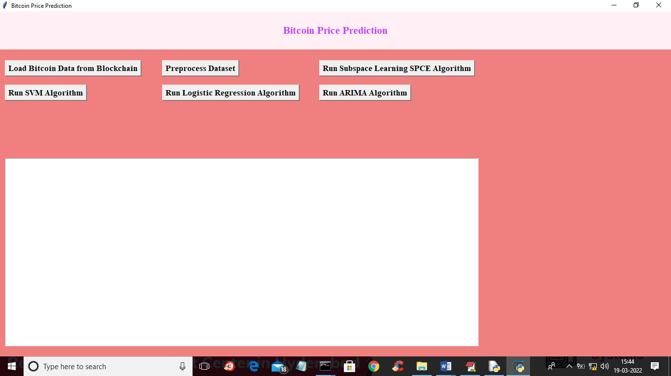
In above screen click on ‘Load Bitcoin Data from Blockchain’ button to load data from Blockchain and get below output
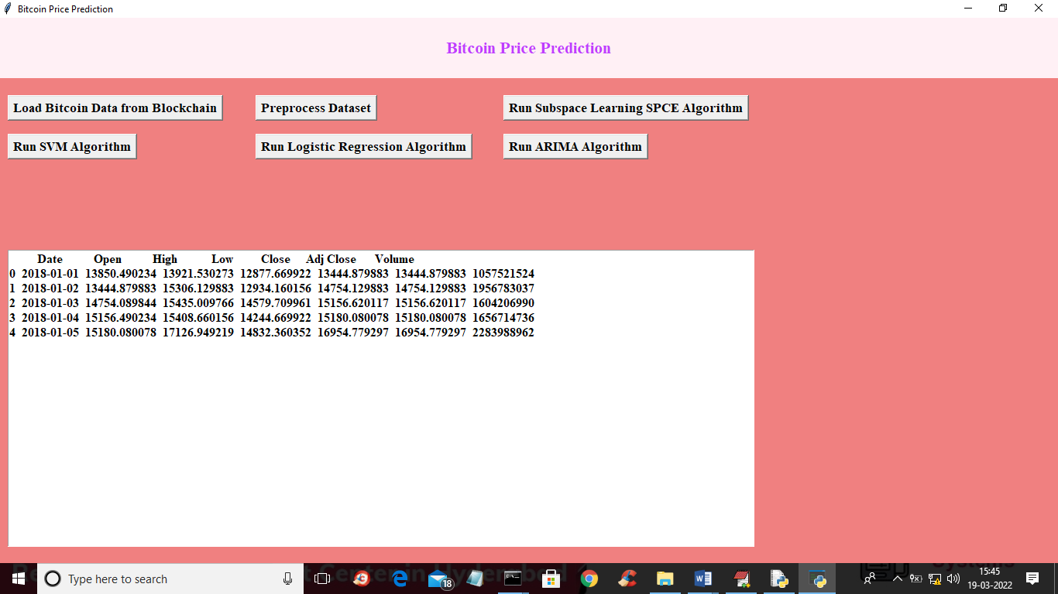
In above screen dataset loaded from Blockchain and now click on ‘Preprocess Dataset’ button to preprocess dataset such as replacing missing values with 0 and then find total attributes before apply SPCE
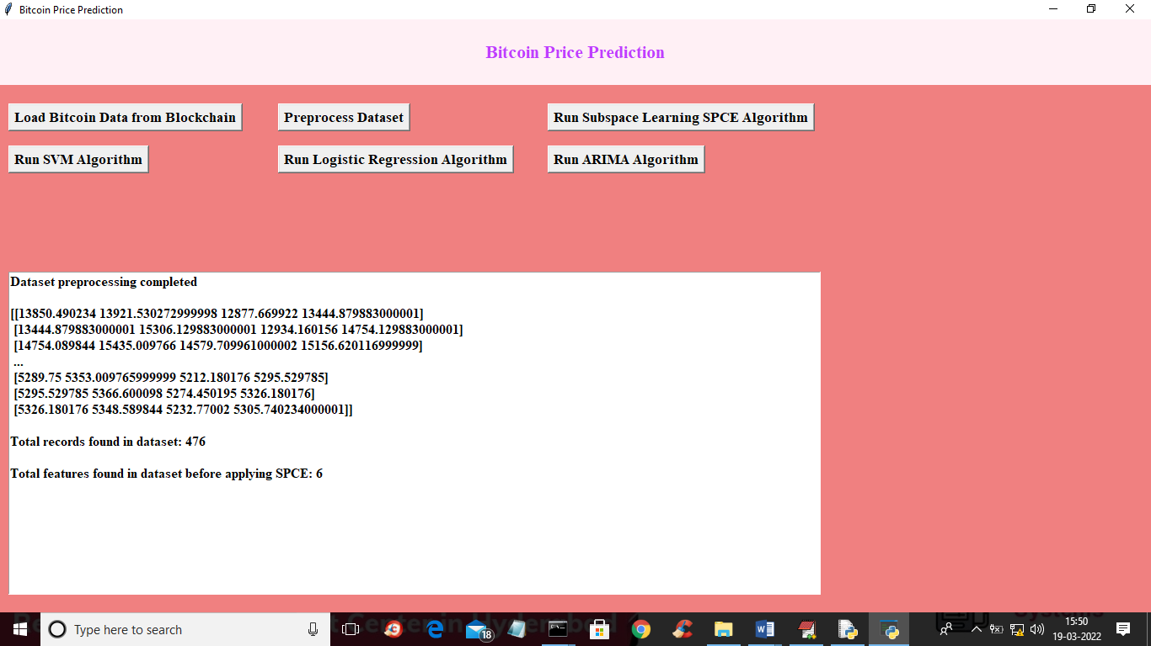
In above screen dataset is normalized and then we can see dataset contains total 476 records and before applying SPCE dataset contains 6 attributes. Now click on ‘Run Subspace Learning SPCE Algorithm’ button to apply SPCE algorithm to reduce high dimension 6 attributes to low dimension and then will get below output
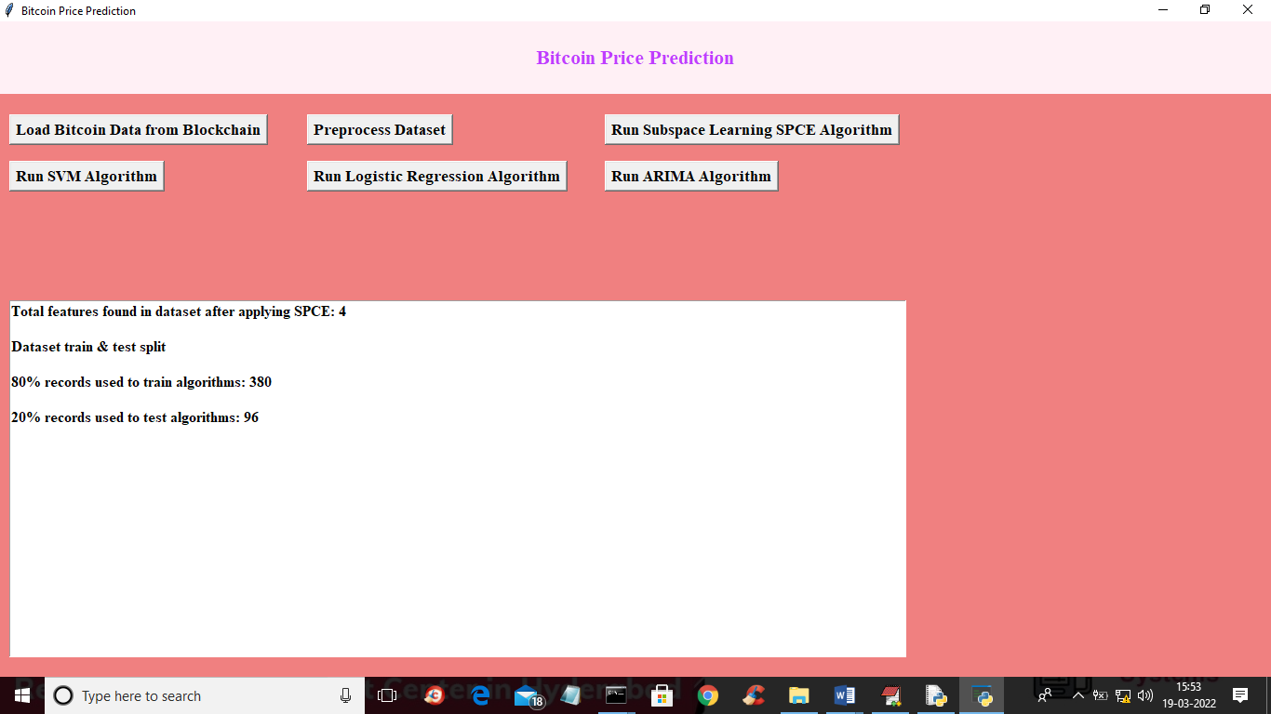
In above screen after applying SPCE attributes/features size reduced to 4 from 6 and we can see application using 380 records for training and 96 records for testing. Now dataset is ready and now click on ‘Run SVM Algorithm’ button to train SVM and get below output
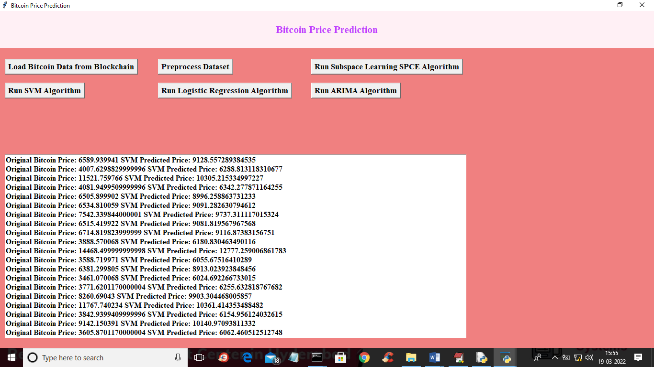
In above screen we can see original Bitcoin prices and then we can see Bitcoin predicted prices and below graph showing difference between original and predicted prices
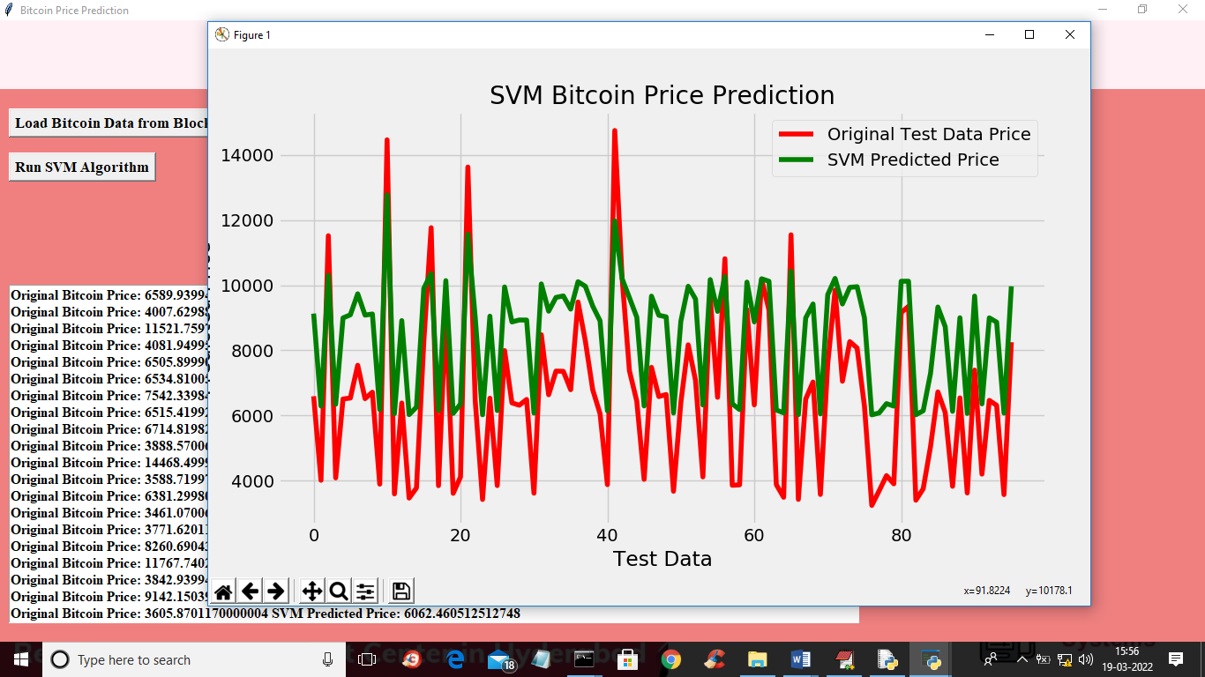
In above graph x-axis represents DAYS/DATE and y-axis represents Bitcoin prices and red line represents original prices and green line represents predicted prices. In above graph we can see there is huge difference between predicted and original prices so we can say SVM is not accurate and now close above graph and then click on ‘Run Logistic Regression Algorithm’ button to train LR and get below output
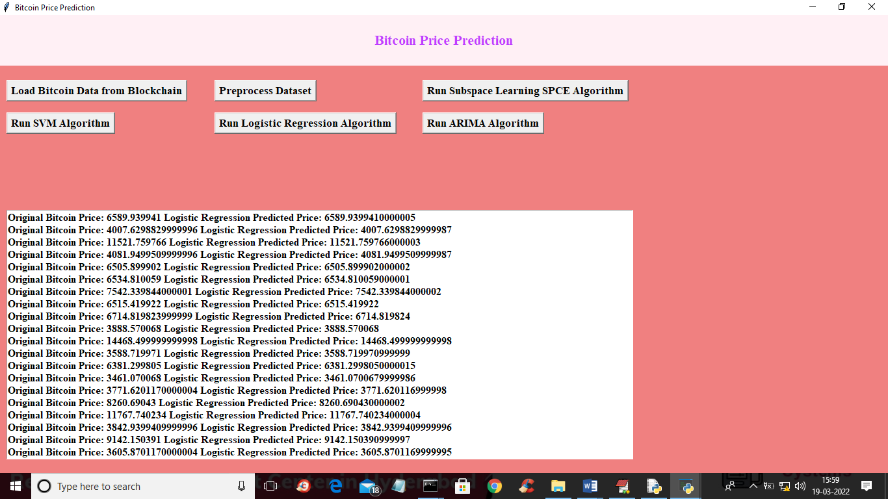
In above screen we can see logistic prediction prices and original prices and below is the LR graph of price prediction
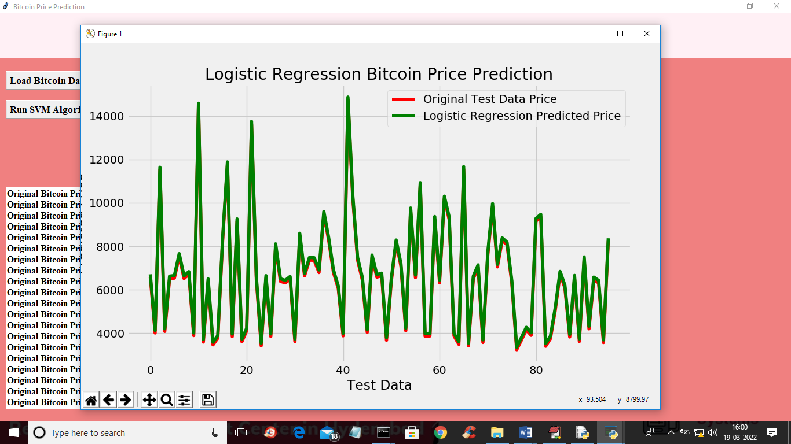
In above graph we can see LR is giving accurate price prediction as both lines are fully overlap and we can see there less difference between both lines so LR is accurate and now click on ‘Run ARIMA Algorithm’ button to train ARIMA and get below output
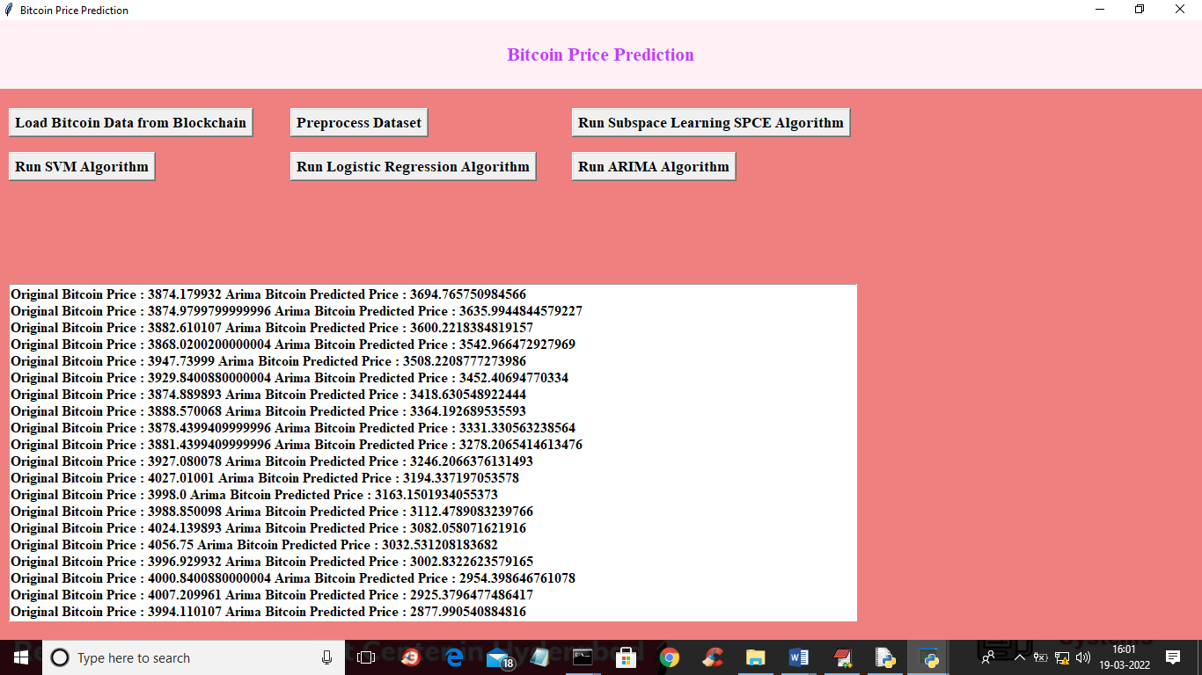
In above screen we can see original and ARIMA predicted prices and below is the ARIMA prediction graph
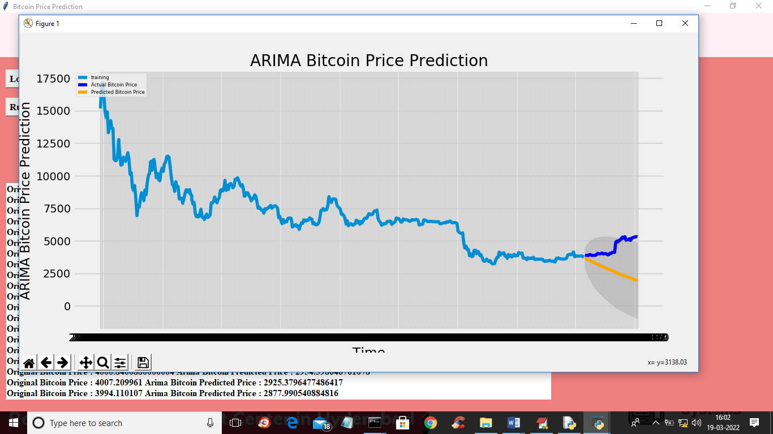
In above ARIMA graph light blue line is the training prices and dark blue line is the test data and yellow line is the predicted data and both test and predicted data is shadowed so we can say ARIMA prediction is also accurate.
In this project we have evaluated the performance of SVM, Logistic Regression and ARIMA and in all algorithm Logistic Regression and ARIMA is giving better prediction prices.
8. CONCLUSION

The analytical process starts from data cleaning and processing of missing values, then exploratory analysis and finally model building and evaluation. The best accuracy on a public test set with a higher accuracy score will be found out. This application can be of help to find the bitcoin market price. The model can be further connected to an AI by optimizing it to an Artificial Intelligence environment, we can also automate the model by creating a web application or a desktop application. The thing that we have in our minds for the future enhancement is another kind even though it is related to AI. I
9. REFERENCES
1. BitConduite[1](exploratory visual analysis of entity activity on the Bitcoin Network )by Christoph Kinkeldey,Jean-Daniel Fekete,Tanja Blascheck,Petra Isenberg .[Issue10.1109/MCG.2021.3070303]
2. Paper on enhancing the price of bitcoin’s fluctuation prediction using attentive LSTM and embedding network by Yang Li, Zibin Zheng and Hong-Ning Dai (2020) [2] published by applied journal as an open access article.
3. Lekkala Sreekanth Reddy, Dr.P. Sriramya[3] (2020) [2] Published a research paper on Bitcoin price prediction by making use of Machine learning algorithms in the International journal of scientific and technology research(IJSTR).ISSN 2277-8616.
4. Paper about the prediction of bitcoin price using ML algorithms by Shivam Pandey, Mr.Anil Chavan, [4] (2021), published by IRJET, in volume8-issue5.
5. The forecasting of crypto currency returns and the volume using search engines paper that was published by Muhammad Ali Nasir1, Toan Luu Duc Huynh Sang Phu Nguyen and Duy Duong(2019) [5], in the springer journals.
6. David Garcia’s and Frank Schweitzer’s paper on”Social signals and algorithmic trading of bitcoin”,[6] during 2015 6.
7. Research paper published, 2018, on automated cryptocurrency price prediction using ML[7] , by Ruchi Mital ,Shefali Arora and M.P.S. Bhatia (2018) .
8. Alireza Ashayer’s , “Modeling and prediction of cryptocurrency prices using machine learning techniques,”[8] June (2019) . Electronic copy available at: https://ssrn.com/abstract=4128261
9. Neha Mangla, Akshay Bhat, Ganesh Avabratha, Narayana Bhat. Cryptocurrencies Market price prediction using Data Science process [9] 2018;ISSN 2321-9653..
10. Edwin Sin , Lipo Wang.Bitcoin price prediction using ensembles of neural networks[10] .2017.publised 978-1-5386-2165-3/17 by IEEE.
11 Franco Valencio, Alfonso Gomez Espinosa, Benjamin Valdes Aguirre [11] paper on price prediction movements of cryptocurrencies using sentiment analysis and ML,published on june 2019, by entropy e21060589.
12. “Price prediction of different crypto currencies using technical trade indicators and ML”, by Mohammed Khalid Salman and Abdullahi Abdu Ibrahim [12], nov 2020,.by IOP conference series.032007.
13. Forecasting and trading cryptocurrencies with machine learning under changing market conditions [13] ,by Helder Sebastiao and Pedro Godinho published by Ideas. s40854-020-00217-x.
14. How to compare the machine learning models and algorithms [14], by Samadhritha Gosh,published in neptune blogs in 2022.
15. Azim Muhammad Fahmi, Noor Azha Samsudin, Aida Mustapha ‘s paper on ,“Regression based analysis of bitcoin prediction”, [15] , published in the year 2017.
16. The paper published by Ladislav Kristoufek, [16] on,”What are the main drivers for bitcoin price”, during 2015,published by research gate.280044258-rs.

